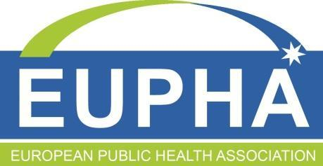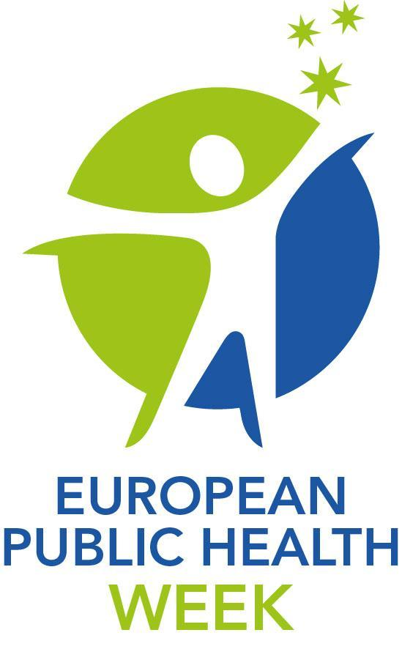
[Add your country EUPHW logo – available at https://eupha.org/media_toolkit]

[Insert catchy, short headline:
what is the main news about your country or organisation’s engagement in EUPHW?]

Subheading [leave as it is or adjust if necessary:]
The third edition of the European Public Health Week starts on Monday
with more than 200 events organised by 40 countries in 19 languages

INSERT DATE OF RELEASE
For immediate release

The public health community across Europe answered the call to join forces for healthier populations, with 40 countries registering more than 200 events in 19 languages for the third edition of the European Public Health Week (EUPHW), which takes place between 17 and 21 May 2021. [Insert country] will host xx event(s).

Initiated by the European Public Health Association (EUPHA), co-funded under an operating grant from the European Union’s Health Programme and supported by the WHO Regional Office for Europe, the initiative dedicates each day to a specific public health theme, including a kick-off webinar every morning of the week led or co-led by key European and international organisations.

Monday will focus on ‘Communicating science and health’, covering sub-themes such as infodemic management and health literacy. ‘New challenges in mental health’ is the theme of Tuesday, particularly relevant as loneliness and isolation caused by COVID-19 and its mitigation efforts have aggravated mental health problems. Wednesday reminds Europeans of the importance of ‘Your local community’ and the potential impact of local solutions to tackle global public health problems, such as climate change. An invitation for multiple sectors to work together to protect the ecosystem shared by animals, plants and humans inspires the theme of Thursday: “All for one health”. Last but not least, ‘Leaving no one behind’ on Friday launches a call to reduce health inequalities that have been exacerbated by the pandemic.

The event(s) in [country] will consist of [insert details of event(s) including date, time, format, title, theme, organisers]

Activities range from local, regional and international lectures and webinars to photo competitions, launch of publications, social media campaigns, virtual exhibitions, movie screenings, online networking gatherings and safe outdoor physical activities at a time when the pandemic still requires social distancing.

Initiated by the European Public Health Association (EUPHA), co-funded under an operating grant from the European Union’s Health Programme and supported by the WHO Regional Office for Europe, the initiative kicks off with a webinar that brings together a rich panel of speakers who will address and answer questions about each of this year’s themes.

Insert up to 3 quotes from representatives of your country or organisation who may be contacted by journalists to answer questions about your involvement in the European Public Health Week. For example:

“[Name, Surname], president of [Organisation] in [country], said: “We decided to host these events because…”

For more information, visit www.eupha.org/EUPHW [insert direct link to your event(s)]

ENDS

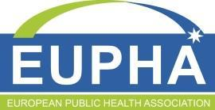
NOTES TO EDITORS
- View the full EUPHW events calendar at https://eupha.org/EUPHW_Search_for_an_event
- Five featured webinars co-hosted by EUPHA to kick off each EUPHW theme:
  - 17 May, 10:30-12:00 CET: “Infodemic management: Social listening to public health action.” - Hosted by the World Health Organization’s Information Network for Epidemics (EPI-WIN). Register at http://www.tinyurl.com/InfodemicManagement
  - 18 May, 11:00-12:30 CET: “COVID-19 impact on people with mental health conditions and beyond”. – Hosted with GAMIAN-Europe. View programme here and register at http://www.tinyurl.com/EUPHAGAMIAN
  - 19 May, 10:00-11:00 CET: “Local spaces and places - How healthy is your city?” - Hosted by WHO Europe Healthy Cities Network. Register at http://www.tinyurl.com/YourHealthyCity
  - 20 May, 10:00-11:30 CET: “Sustainable and nutritious diets for healthier populations”. Hosted with EFAD. Register at https://tinyurl.com/EUPHAEFAD
  - 21 May, 10:00-11:30 CET: “COVID-19 and Health Inequalities: applying the lessons to deliver change”. Hosted with EuroHealthNet. Register at http://www.tinyurl.com/EUPHAEuroHealthNet
- [insert other relevant links about your event(s)]
- Learn all you need to know about the European Public Health Week in less than 2 minutes (video): https://youtu.be/v94BcO5abb8
- Official hashtag of the Week: #EUPHW
- Access the press & media dissemination kit (including visual graphics for web and social media): https://drive.google.com/drive/folders/1AH_J4y2obaajKi1HYVqwjpcOEeEPbs3G?usp=sharing
- For media queries or any questions, please contact [name and contact details of person in your organisation responsible for liaising with the media]

Countries with registered EUPHW events: Albania, Austria, Belgium, Colombia, Bosnia Herzegovina, Brazil, Bulgaria, Cyprus, Czech Republic, Denmark, Ethiopia, France, Georgia, Germany, Greece, Hungary, Ireland, Israel, Italy, Lithuania, Luxembourg, Malta, Nepal, Netherlands, North Macedonia, Norway, Poland, Portugal, Republic of Kosova, Romania, Russia, Serbia, Slovakia, Spain, Sweden, Switzerland, Turkey, Ukraine, United Kingdom, USA.
Languages of EUPHW events: English (90), Bulgarian(41), Portuguese (24), Russian (11), German (11), Greek (7), Italian (5), Hungarian (5), Georgian (4), Spanish (4), Serbian (3), Croatian (2), Albanian (1), French (1), Romanian (1), Ukrainian (1), Bosnian (1), Swedish (1), Turkish (1).

What is EUPHA?
The European Public Health Association, or EUPHA in short, is an umbrella organisation for public health associations in Europe. Our network of national associations of public health represents over 23’000 public health professionals. Our mission is to facilitate and activate a strong voice of the public health network by enhancing visibility of the evidence and by strengthening the capacity of public health professionals. EUPHA contributes to the preservation and improvement of public health in the European region through capacity and knowledge building. We are committed to creating a more inclusive Europe, narrowing all health inequalities among Europeans, by facilitating, activating, and disseminating strong evidence-based voices from the public health community and by strengthening the capacity of public health professionals to achieve evidence-based change.
EUPHA’s definition of Public Health
“The science and art of preventing disease, prolonging life and promoting health and well-being through the organised efforts and informed choices or society, organisations, public and private, communities and individuals, and includes the broader area of public health, health services research, health service delivery and health systems design.”

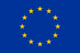 The European Public Health Week received co-funding under an operating grant from the European Union’s Health Programme (2014-2020).

