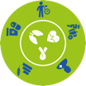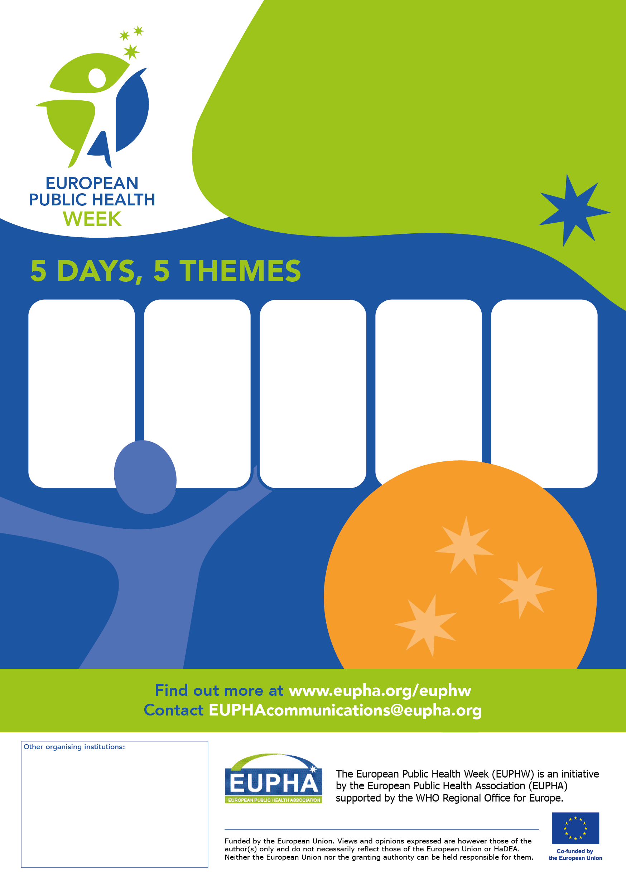

**GET**

**INVOLVED!**

Organise your own activity

**[Event Host]**

Spread the word **[Disseminator]**

Join events online or   
where you live **[Participant]**

For **all professionals** and  
**citizens** contributing to better  
public health at local, national,  
regional and European level.

FRIDAY

26 May

Global health emergencies and response

THURsday

25 May

Prevention

and control of chronic diseases

Monday

22 May

Mental health

for all

TUESDAY

23 May

Diversity

in health

Wednesday

24 May

Access

to care

FRIDAY

21 May

Leaving no

one behind

Public health: global issues, local actions

22-26 May 2022

Join the 5th European

Public Health Week!

#euphw