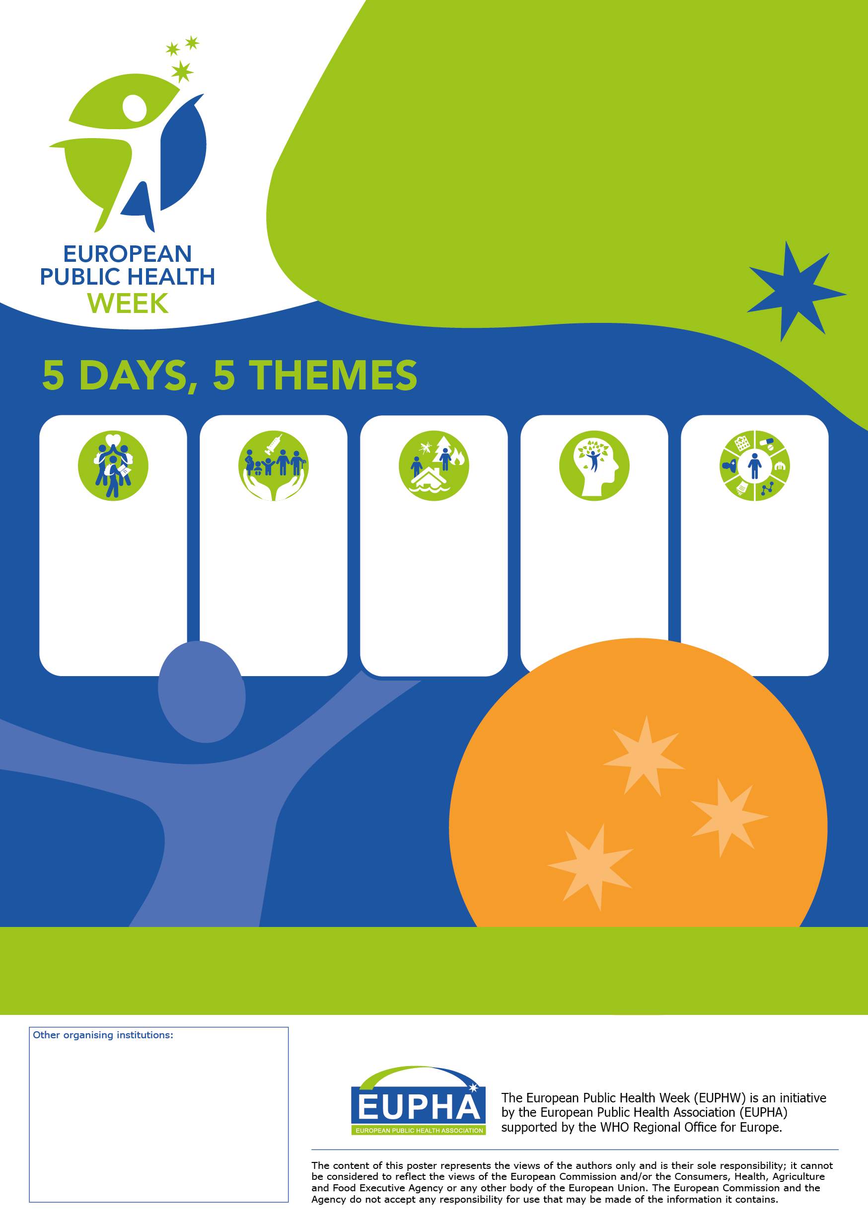

**GET**

**INVOLVED!**

Organise your own activity

**[Event Host]**

Spread the word **[Disseminator]**

Join events online or   
where you live **[Participant]**

For **all professionals** and  
**citizens** contributing to better  
public health at local, national,  
regional and European level.

**Find out more at** [**www.eupha.org/euphw**](http://www.eupha.org/euphw)

**Contact** [**EUPHAcommunications@eupha.org**](mailto:EUPHAcommunications@eupha.org)

FRIDAY

20 May

Building

resilient health systems

THURsday

19 May

No health

without mental health

Monday

16 May

A healthy and health literate youth

TUESDAY

17 May

Vaccination as key prevention strategy

Wednesday

18 May

Climate change affects our

health

FRIDAY

21 May

Leaving no

one behind

Health throughout the life course

16-20 May 2022

Join the 4th European

Public Health Week!

#euphw