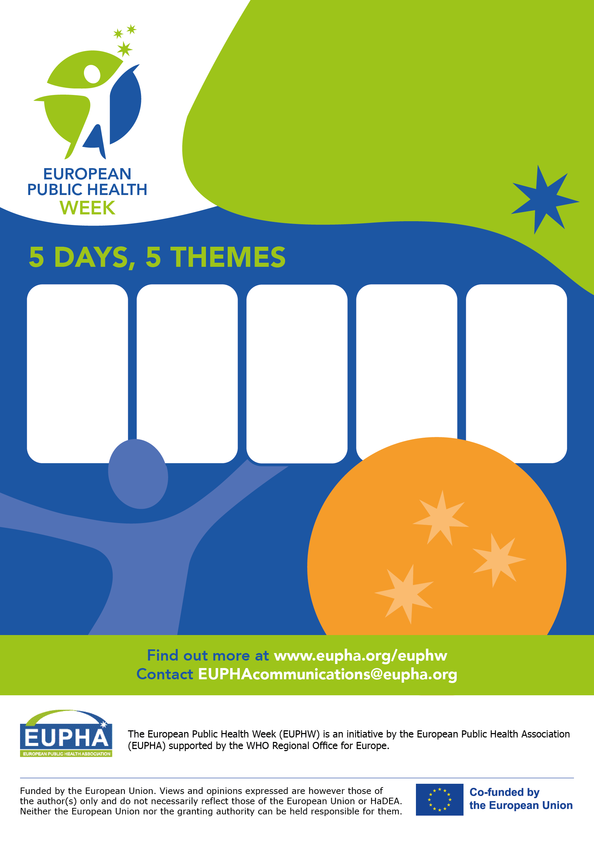

FRIDAY

17 May

Next generation: Public health leaders of tomorrow

THURsday

16 May

Health through the life course: Breaking down silos

Wednesday

15 May

Planetary health: A *glocal* approach

TUESDAY

14 May

Mental health: People at the centre

Monday

13 May

Health is a political choice

**GET**

**INVOLVED!**

Organise an event!

Spread the word!

Join events!

For **all professionals** and  
**citizens** contributing to better  
public health at local, national,  
regional and European level.

FRIDAY

21 May

Leaving no

one behind

Health is   
a political choice!

13-17 May 2024

Join the 6th European

Public Health Week!

#euphw #EUPHW2024